Renesas Flash Programmer

User Manuel

Renesas_Flash_Programmer is a GUI tool developed by Renesas Electronics for offline firmware burning. It has the following features:

* Can be used for chip initialization (can be used for unbricking).
* Supports multiple methods such as J-Link/USB-Boot/UART for firmware burning.

**Instruction of Use**

# Create Project:

# Micro-controller defaults to RA

# Project name: you can define it as you want

# Project Folder: Configuration file storage path

# Download method: Usually, select Jlink/COM Port

Note: COM-port is used to enter Boot mode for firmware burning via USB-FS.

# 2、Burning Configuration:

**Method 1: Boot Mode Download**   
Firstly, the chip needs to enter Boot mode, then select the firmware to burn, and finally click Start to begin the download.

## Entering Boot Mode:

* Insert the Type-C data cable into the development board's USB-OTG port.
* Press and hold the BOOT button on the development board, then press the RST button. Next, release the RST button. At this point, the chip enters Boot mode. Select the firmware for burning.

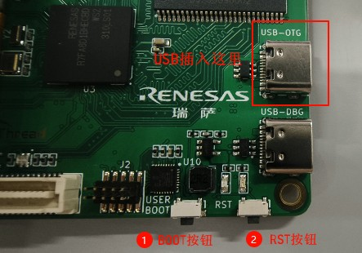

Select the firmware for burning.

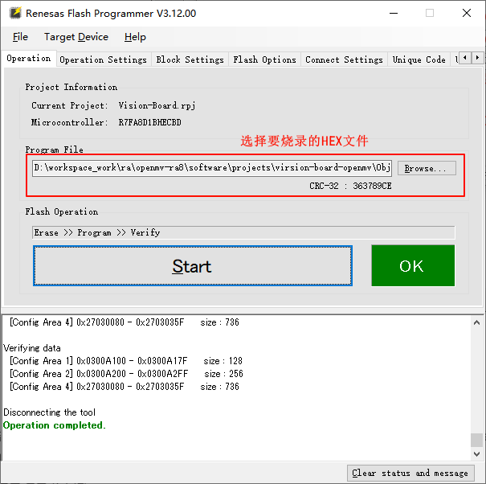

# Method 2: Jlink Download Preparation: You need to prepare a Jlink and a [JTAG SWD 10-pin IDC](JTAG SWD 10pin IDC ) cable.

Insert the JTAG connector into the development board as follows:

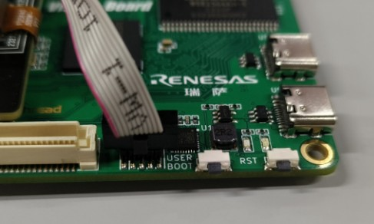

## Switch the download mode to J-Link.

## Enter the Connect Settings interface, switch the download mode to J-Link, and select the SWD interface.

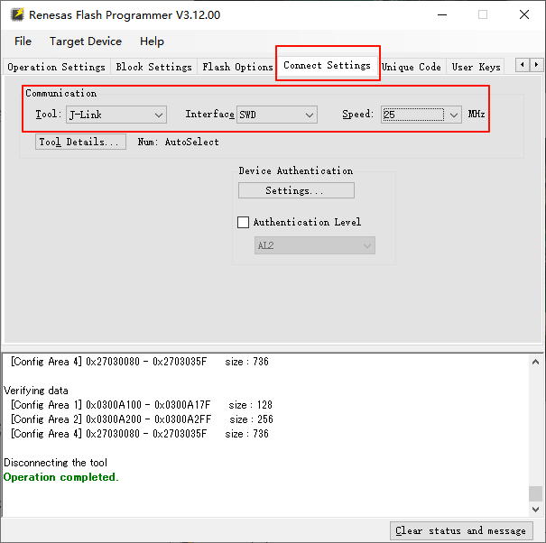

**Select the firmware for burning.**



# 3、Unbricking Method

If the chip cannot be burned, you can initialize the chip using the following method.

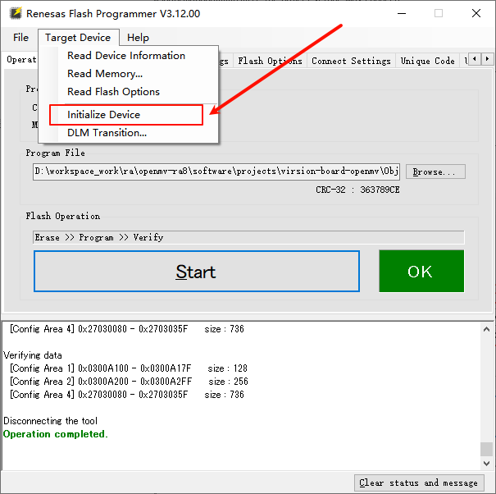

# Q&A

Q: After clicking download firmware, the following error occurs: Error(E0000305): The program file exceeds the flash memory size of the target device.   
  
Operation failed.   
  
A: Refer to the solution in the following figure:

